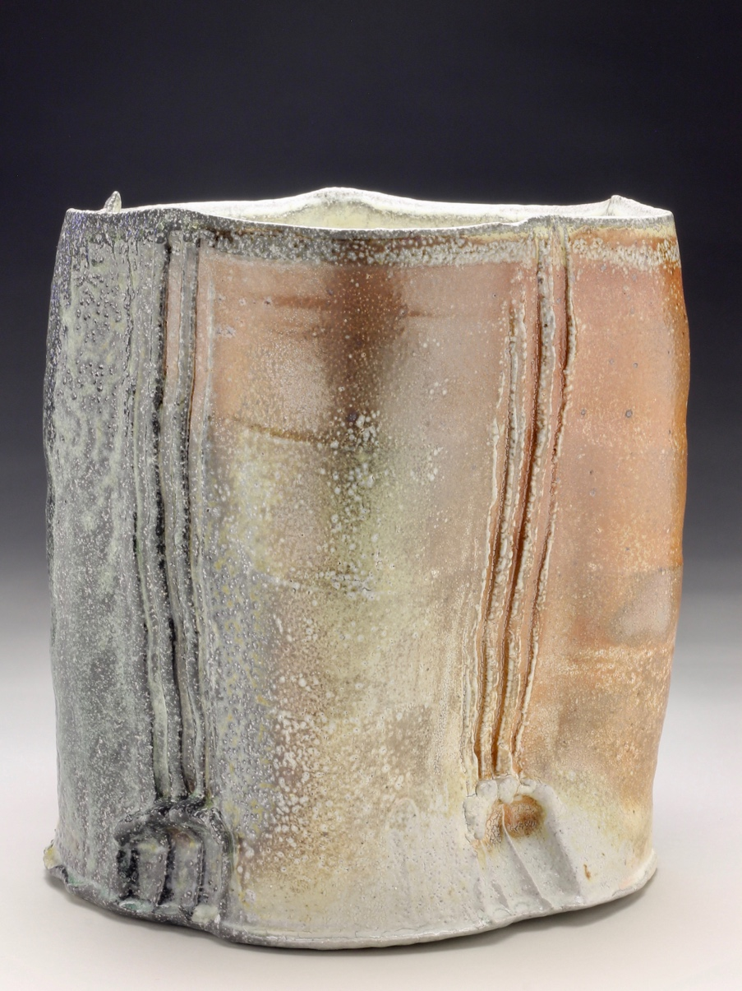
University of Missouri
School of Visual Studies
& Art Program

For more information, contact:
Catherine Armbrust
Director
George Caleb Bingham Gallery
armbrustc@missouri.edu
(816) 718-3742

FOR IMMEDIATE RELEASE
COLUMBIA- (February 13, 2019)

DOXA: PRAYERFUL POTS - MFA Thesis Exhibition by Eric Ordway Opens at Bingham Gallery

Location: Fine Arts Building, Room A125. 505 Hitt Street, Columbia, MO 65211
Dates: March 11th-15th, 2019
Artist Talk & Reception: Thursday, March 14th, 2019, 4:30-6:30PM

The University of Missouri’s George Caleb Bingham Gallery presents MFA candidate Eric Ordway’s solo thesis exhibition, DOXA: PRAYERFUL POTS, which is comprised of works in functional and sculptural ceramics. DOXA: PRAYERFUL POTS explore the themes of functional wheel thrown pottery and the source of creative activity in western, Judeo-Christian art theory.
Ordway was born in Columbia, MO in 1984. He holds a BFA in ceramics from Colorado State University-Pueblo in Pueblo, CO and is a candidate in Ceramics at the University of Missouri. His work has been exhibited both nationally and regionally, including most recently at the 2019 MACC: Alumni Show at Moberly, MO and at the Sager Braudis Gallery in the May Exhibit of 2018. He was an artist in residence at the Morean Center for Clay in St. Petersburg, FL in 2016 and is looking forward to serving as a workshop assistant with Joe Pintz at the Penland School of Craft in Bakersville, NC this summer.

For more information, contact Catherine Armbrust at George Caleb Bingham Gallery
via phone (816) 718-3742 or email (ArmbrustC@missouri.edu).

